Documentary Poem Unit: Final Project
Part I: The Zero Draft
Due: Tuesday, 9/28. Upload to ICON before class.
We will begin the process of writing by invoking what John Trimbur terms “the call to write.” In Trimbur’s calculation, “the call to write” is the urge we feel or the impulse we have when we have something to say. Drawing from Trimbur, I invite you to begin the composition process by considering what you want to say.
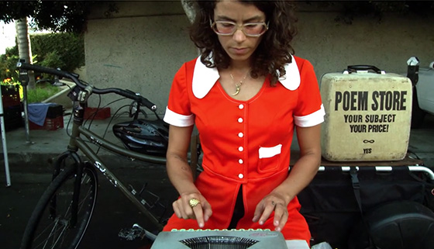
Tonight, for homework, you will spend 20 minutes freewriting about a topic or topics that interest you. What are you passionate about? What needs to be said or voiced? What moment in history is in need of documentation? Maybe you want to take up the Chibok Government Secondary School kidnapping, the activism of Malala Yousafzai, the LGBTQ movement, or current debates about minimum wage.

My suggestion is to begin with (1) a historic event, (2) a person, or (3) a movement. In your freewrite, explain what / who your topic is and its overall significance. Assume that your audience has no knowledge of this topic. Provide a detailed explanation / exploration of the topic.
*Remember, this is a freewrite, which means you should write without stopping for the full 20 minutes. If you cannot think of something to say about your topic, write “I am thinking” until you find something to add. You can write in paragraph form (or not). You can list (or not). Spelling and grammar are irrelevant.
Have fun and Happy Writing!

For more information on “The Call to Write” see Kessler, Kate. “Composing for Delivery.” The English Journal 95.2. (Nov. 2005): 89-96.
Photo Credit: http://www.chrystalyli.com/wp-content/uploads/2014/04/suskin.jpg.

