Documentary Poem Unit: Final Project
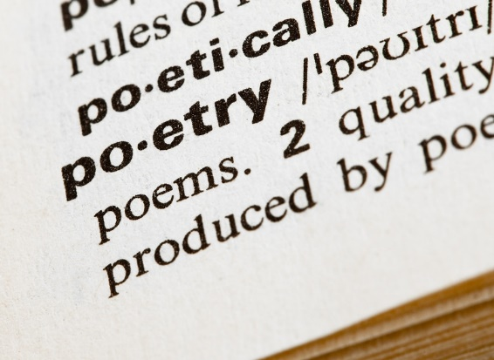
Part II: The Rough Draft
Due: Tuesday, 10/6. Upload to ICON before class AND bring 2 copies to class for in-class workshop.
You have developed a topic, researched that topic, and workshopped your research with the class. Now, it is time to compose your first working draft.
Step One: Formal Decisions
What form will this poem take? Will it take the form of a sonnet? an ode? an elegy? or perhaps it will be free verse? How many stanzas will you include? How many lines per stanza?
Spend 10 minutes freewriting about your formal decisions. In your freewrite, reflect on what formal decisions might make sense and why. You might also consider the forms we have discussed in class and choose to mimic one of our authors.
Step Two: Major themes, people, and places
Next, spend 10 more minutes listing the major themes, people, and / or places that you want to incorporate into your poem. Consider the importance of each selection. Are there particular themes / people / places that should be grouped together or spaced apart?
Step Three: Begin Writing
It’s time to begin the composition process! This part can be both frustrating and exciting. Take your time on this step, but don’t get too hung up on any particular moment. We will have time to workshop ideas and polish these drafts before submitting the final.
In this step you might consider:
- Diction (word choice). Think of the denotations / connotations of the words you choose.
- Detail. What details are particularly important to the scene and / or characters?
- Tone. What tone do you want to set? Choose words that illustrate that tone.
- Enjambment. Are there moments where it might makes sense to delay the closing of the sentence between poetic lines?
- Repetition. Will you include incremental or exact repetition?
- Poetic feet. Are you going to try out iambic pentameter? or maybe dactylic trimeter?
- Figurative Language. Maybe you would like to include a metaphor or simile?
- Dialogue. What are the characters saying? To whom are they speaking?

Photo Credit: http://imavex.vo.llnwd.net/o18/clients/smekenseducation/images/Organization/poetry-in-dictionary.jpg.

